Full Name
Position

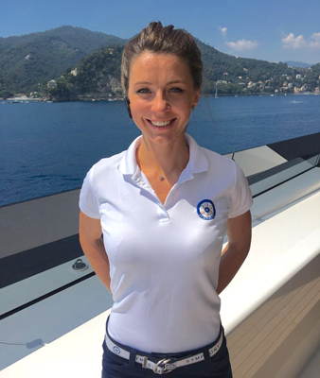
Nationality:
D.O.B:
Visas:
Languages:
Driving Licence:
Email:
Skype:
Phone:
Health:
Smoker/Tattoo(s):

PROFILE

Tell us about you, what are your goals and achievements, where do you see yourself in 5 years and what do you want out of life in the yachting industry?

CERTIFICATES

School, university, yachting qualifications, STCW, Security Awareness, Master 3000, OOW, Silver service, PADI etc…

YACHTING EXPERIENCE

Yacht Name (size) Position (Dates onboard)
Areas Cruised.

Description of role and duties onboard

Yacht Name (size) Position (Dates onboard)
Areas Cruised.

Description of role and duties onboard

Yacht Name (size) Position (Dates onboard)
Areas Cruised.

Description of role and duties onboard

OTHER EMPLOYMENT

Where Position (Dates)
South Australia

Description of Duties

SKILLS

Silver Service
Napkin Folding
Flower Arranging
Fibre Glass
Painting & Varnishing

INTERESTS

Max 3 interests such as reading, diving, yoga.

REFERENCES

Name and Position
Contact number
Contact email

Name and Position
Contact number
Contact email

Name and Position
Contact number
Contact email

Name and Position
Contact number
Contact email

